**Project Title: Sales Data Analysis and Forecasting**

**1. Project Objective**

* Analyze the sales data for a company to identify trends, patterns, and insights that can help make informed decisions.
* Forecast future sales based on historical data.

**2. Data Collection**

* **Dataset**: Obtain a dataset with sales data, such as sales transactions, customer demographics, product categories, sales channels, etc.
* Example data columns:
  + Date
  + Product Name/Category
  + Quantity Sold
  + Unit Price
  + Total Sales
  + Sales Region

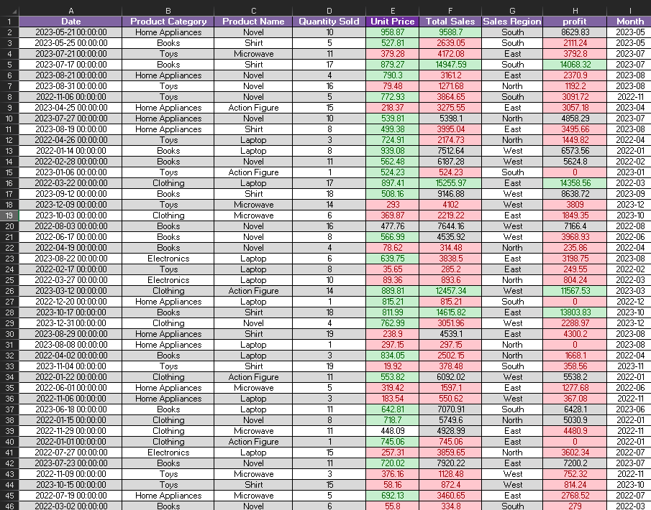

**3. Data Cleaning and Preprocessing**

* **Remove duplicates**: Check for and remove duplicate rows.
* **Handle missing data**: Identify and handle missing values (using average values or interpolation if necessary).
* **Standardize formats**: Ensure all data is in consistent formats (dates, currency, etc.).
* **Create calculated columns**:
  + Total Sales = Quantity Sold * Unit Price
  + Profit = Total Sales - Cost (if applicable)



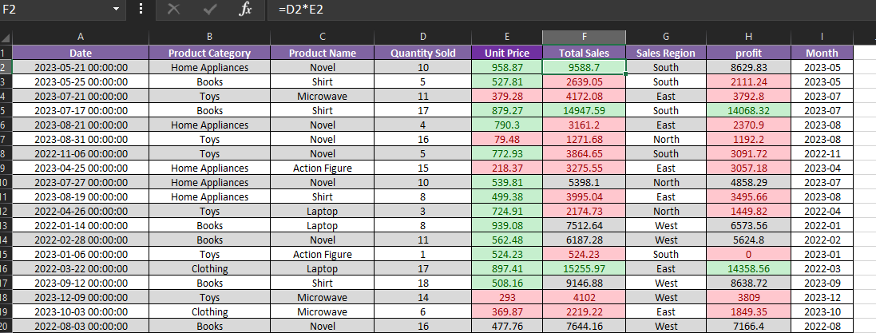

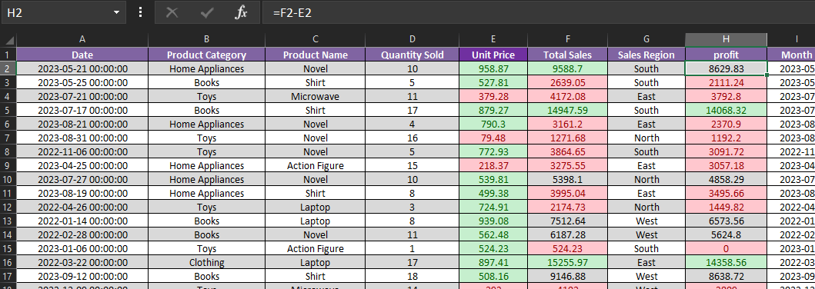

**4. Exploratory Data Analysis (EDA)**

* **Descriptive Statistics**: Calculate the mean, median, standard deviation, minimum, and maximum values for sales, quantities, etc.



* **Pivot Tables**:
  + Create pivot tables to summarize data (e.g., total sales by product category, by month, by region).

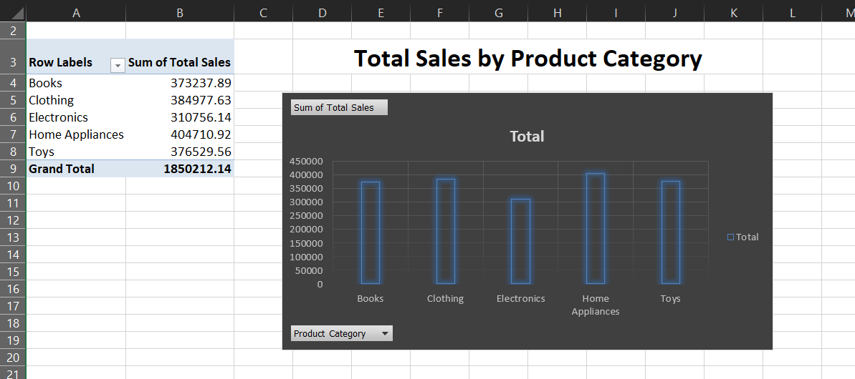

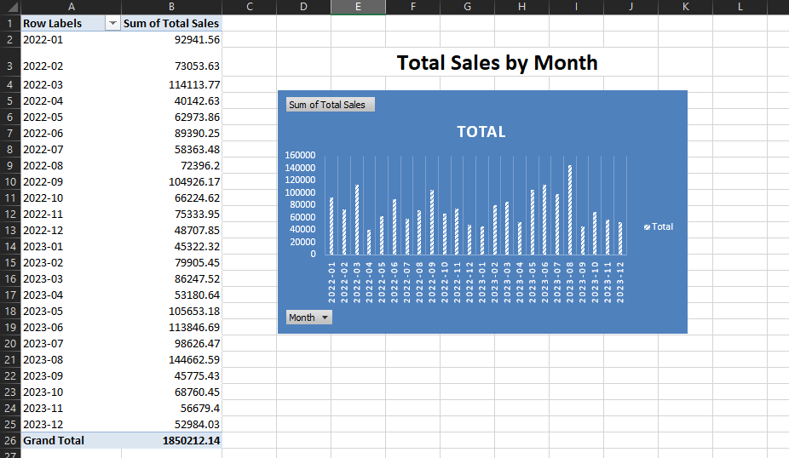

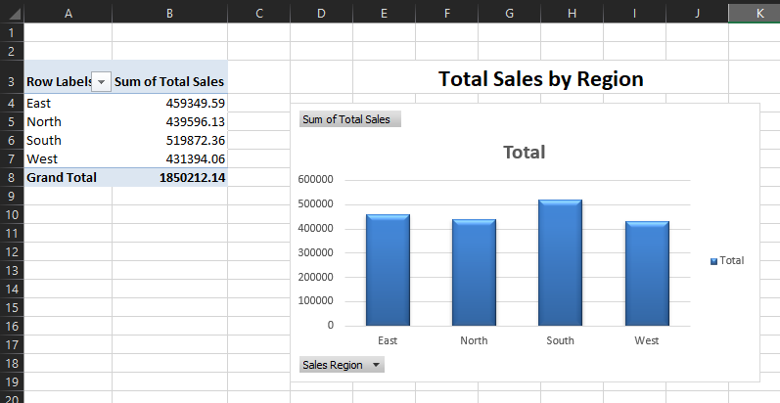

* **Trend Analysis**:
  + Plot line charts to visualize sales trends over time.

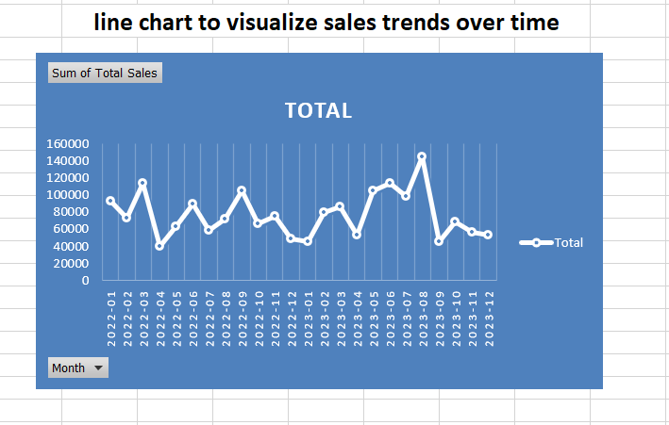

* **Correlation Analysis**:
  + Use scatter plots or correlation matrices to explore relationships between different variables (e.g., how product category correlates with sales).

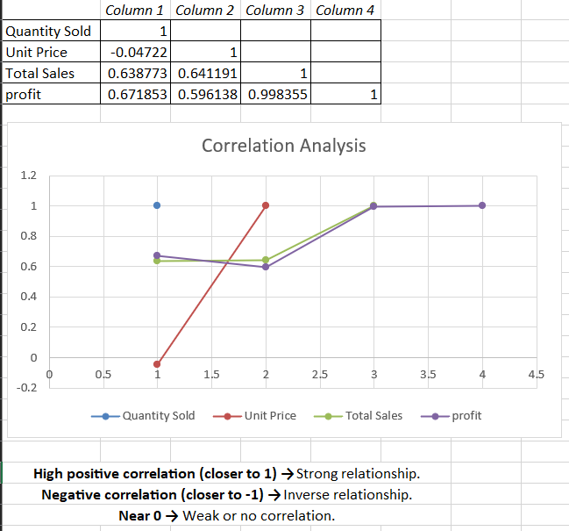

**5. Data Visualization**

* **Charts**:
  + Use bar charts for comparing sales across categories or regions.

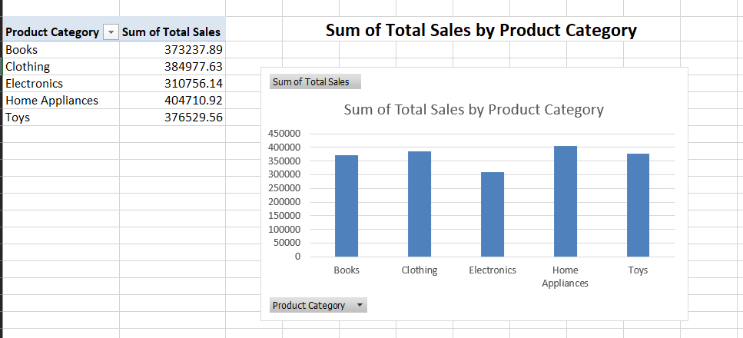

* + Create pie charts for market share analysis (e.g., sales distribution by product).

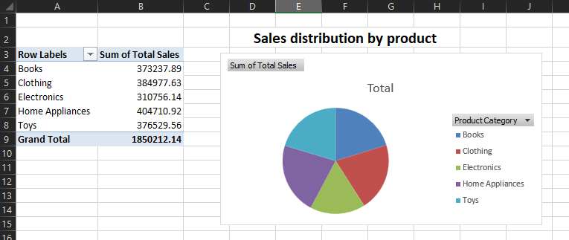

* + Line graphs for sales trends over time.

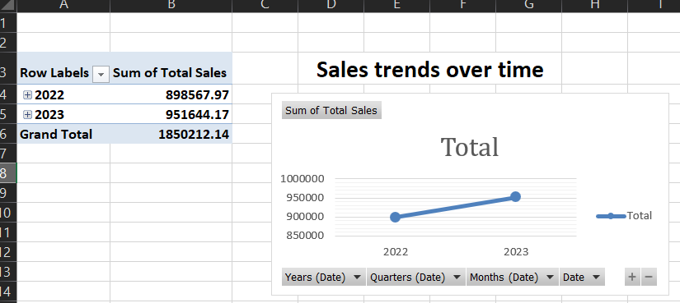

* **Conditional Formatting**:
  + Use color scales to highlight high/low sales values or performance.

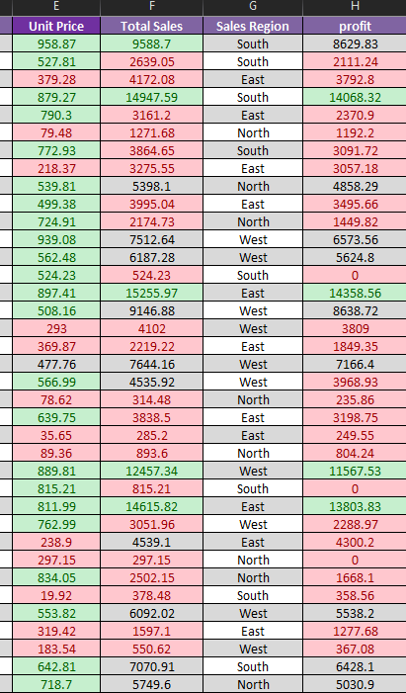

* **Slicers/Filters**:
  + Add slicers for interactivity to filter data by region, date, or product category.

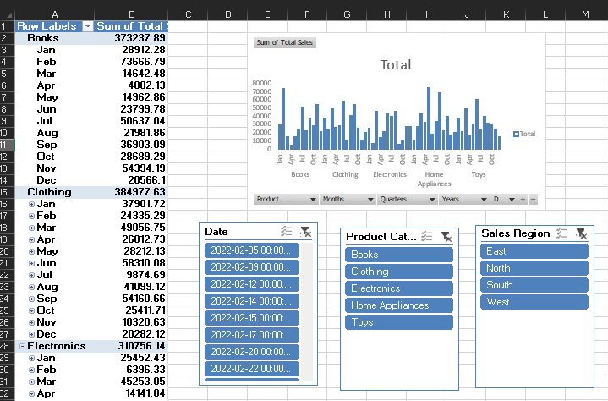

**6. Sales Forecasting**

* Forecast the sales based on the previous trends.

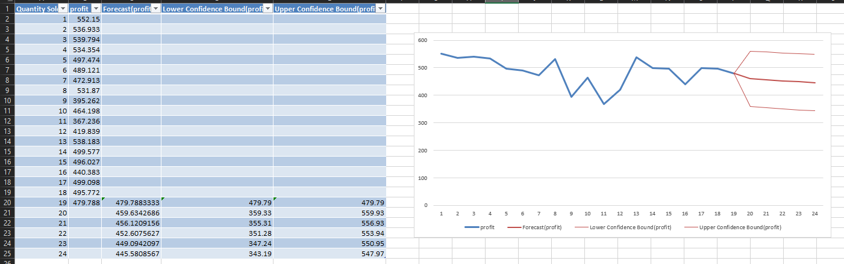

**7. Reporting**

* **Dashboard**: Create an interactive dashboard with key metrics (e.g., total sales, average sales per product, sales growth rate).
* **Summary Tables**: Create summary tables for executive reports, including insights on top-performing products, best sales periods, etc.
* **Actionable Insights**: Based on your analysis, provide recommendations such as which products to promote, which regions to focus on, etc.

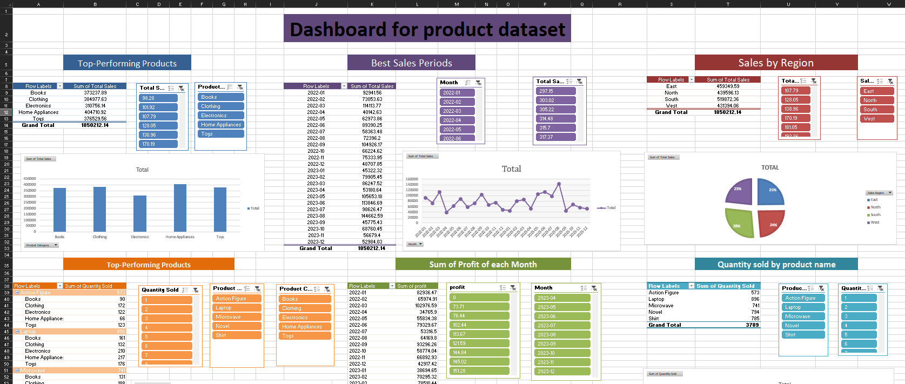

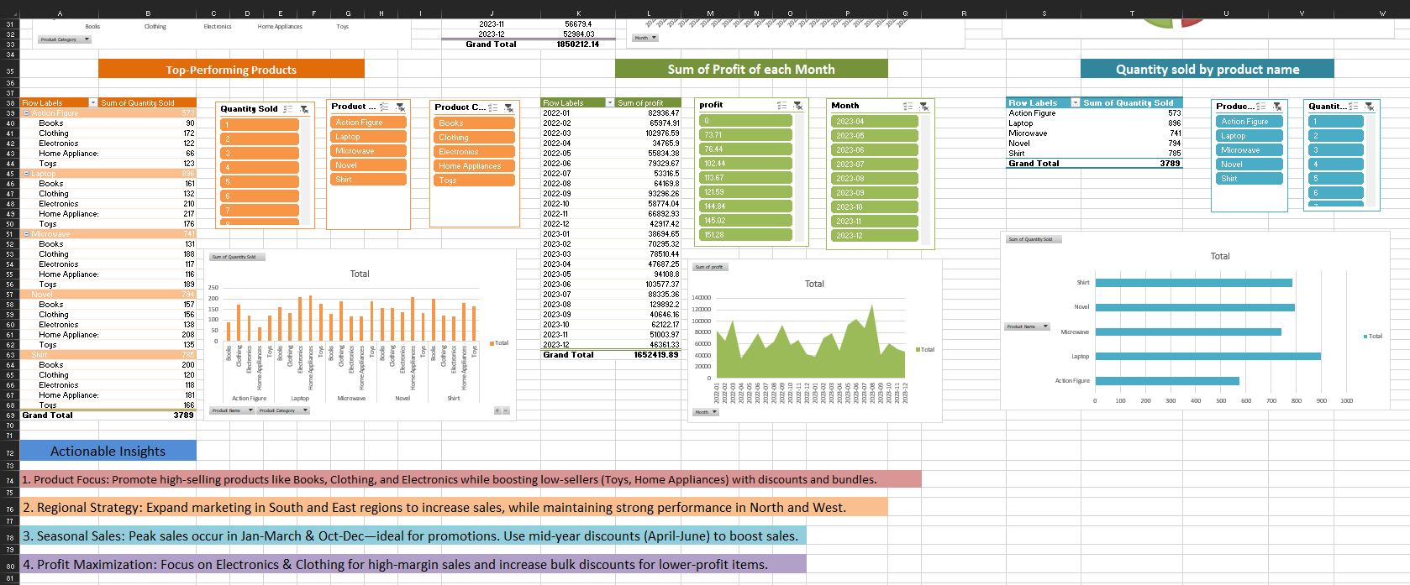

**8. Final Deliverables**

* An Excel file with clean data, analyses, visualizations, and forecasting models.
* A brief report or presentation summarizing key insights, trends, and recommendations.

Ppt link:-

https://www.canva.com/design/DAGjN_AAz84/JsPUlLr2b6NFntU9Mvb4rw/edit?utm_content=DAGjN_AAz84&utm_campaign=designshare&utm_medium=link2&utm_source=sharebutton